Registration Form

4^{t}h Edition

General data
Title: Name: Surname:

Afﬁliation: Email: Phone: Fax:
Address: Cap/District: City: Country:

Contribution

All presentations will be accepted if at least one of the authors is registered and present at the symposium.

Oral Registration fee
Poster

ATTENTION: mark the box of the table pertinent to your position
Early Registration (€)* Late Registration(€)**
EMASST- Member | 150 | 200
Non EMASST- Member | 200 | 250
Student | 100 | 150
Accompanying person | 75 | 100
EMASST membership 50€ (per year)

*Early registration (until December 20, 2023)
** Late registration (after December 20, 2023)

Note that the payment of registration fee could be done by means of Bank transfer using the following data:

Bank data
IBAN: IT67J0200805198000102402864
Checking account: BANCA UNICREDIT, address Via delle Montagne Rocciose Rome, Italy Holder: ASSOCIAZIONE EUROPEA DELLA SCIENZA DELLE SUPERFICI DEI MATERIALI
Causal: registration «European Symposium on Surface Science-Athens 2024»

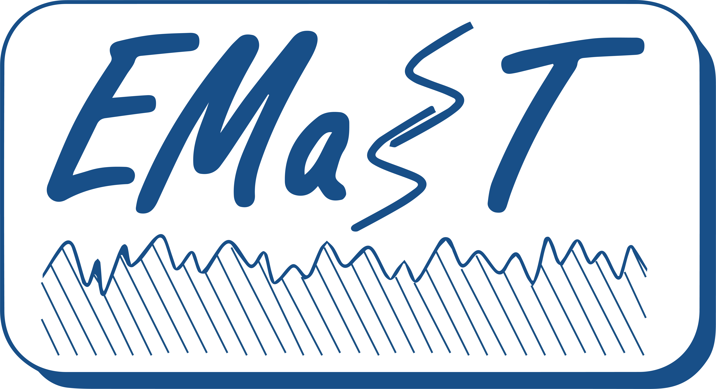
Please ﬁll and send the form to info@emasst.com
European Association of Material Surfaces Science and Technology

